**IT24400067**

**Perera M.C.D**

**IT2120 - Probability and Statistics – Lab Sheet 07**

**Exercise**





1. 
2. 

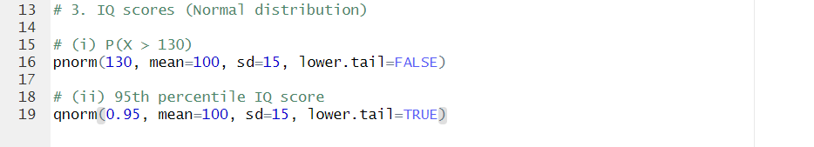3)

